Meet the Binnewaters
Lesson 20230123.01 (non-local classes)

Stories surround us. Some may be true and some are pure fiction. How can we tell the difference? What are the clues that indicate the credibility of a story? How can we, as readers and listeners, discern historical truth from fiction?

Objectives: Students will examine historical records and identify clues (literary, linguistic, cultural, chronological) which may or may not support the credibility of those accounts.

Materials: Table of Credibility 20230116 – copies to be distributed
Article: Strange Colony in Ulster 20230115 – copies to be distributed

Time: 40 – 50 minutes

Background
A little over one hundred miles up the Hudson River from New York City lies Ulster County, within which is a place known as Binnewater (pronounced Binny-water). Today Binnewater is an historic district listed on the National Register of Historic Places. In the late 19th and early 20th century Binnewater was a town like other small towns with a railroad depot, a general store, a post office, and several houses. The Binnewater area has been known for its five lakes including Williams Lake, Twin Lakes, and Fourth Lake. At one time there was a lake resort along Williams Lake. The resort had a hotel, a restaurant, and a private beach club. All of this sounds rather respectable.
However, there was a time when the name Binnewater was used to describe something far different. A group of people who lived around the lakes became known as the Binnewaters. It was said that the Binnewaters were outcasts who engaged in behaviors less than acceptable. They were characterized as criminals and people possessing a wide range of undesirable traits.

LESSON I:
This lesson will help students examine the fascinating history of the Binnewaters people.

Getting Started
Remind students of the questions they probably heard in elementary school: during reading.
~ Does it look right?
~ Does it sound right?
~ Does it make sense?
When hearing or reading historical stories, these same questions might be asked about the story facts that are presented.

ASK the students when they hear or read a story, how do they decide if something is true or not.
Accept several responses. List several on the board. Possible responses may include: WHO is telling the story; WHERE the story originates; IF the events in the story seem reasonable; Does the information in the story square with what you already know or think that you know is true. Include on the board any of the above not mentioned.

Addressing the Topic
Distribute copies of the Table of Credibility. Read aloud the historical “facts” listed in section A and ask the students to rate each one on the scale from 5 to 0 with 5 being probably true and 0 being absolutely not true.

Then, with the table displayed on the board, tally results from the class for each fact.

Encourage students to explain their ratings and then invite them to change their ratings based upon class (or outside) discussion.

SECTION A
Table of Credibility
Level of  confidence | 5 probably true | 4 | 3 | 2 | 1 | 0  not true
FACT 1
FACT 2
FACT 3
FACT 4
FACT 5
FACT 1 – George Washington was a general in the Continental Army and the first
President of the United States.
FACT 2 – Rip Van Winkle was a real person who visited the Catskill Mountains.
FACT 3 – The town of Kingston was the first capital of the State of New York.
FACT 4 – The Hudson River sometimes flows north and sometimes flows south.
FACT 5 – The Sioux Indians once settled along the Hudson River.

___________________________________________________________________________________________________________________
For reference only if further discussion is desired
FACT 1 – TRUE
FACT 2 – FALSE – The story of Rip Van Winkle is a fictitious tale written in 1819 by the American author
Washington Irving.
FACT 3 – TRUE – Kingston became the State of New York’s first capital in 1777.
FACT 4 – TRUE – Tidal portions of the Hudson River change direction of flow based upon the tides.
FACT 5 – FALSE – The Sioux Indians never inhabited the Hudson Valley. They primarily lived in what
is today North and South Dakota. The Algonquins and the Leni Lenape were some
of the indigenous people who did live along the Hudson River.
_____________________________________________________________________________________________________________________

SAY to the students – Today I am going to tell you a story. I think it is true, but I’m not really sure. I am curious to see what you think. How many of you have ever heard of Binnewater?
Most likely, there will be little or no familiarity with Binnewater. Tell the students that Binnewater was an old town (now a historic district in Rosendale, Ulster County. NY), where there was once a lakeside resort for tourists. Today the resort is gone but there are several businesses in the area which use the name Binnewater.

TELL the story in your own way, something like this:
It was sometime over a hundred years ago when there was a group of people living in the hills near the town of Kingston NY. The people were known as the Binnewaters – called this because of the name of the lakes around which they lived. Sometime later they were also known as the Jukes.

ASK – How many of you have heard of Kingston, NY?
Tell the students that it is located about 100 miles up the Hudson River from New York City. Kingston is an old town with a rich history.

Continue with the story:
The Binnewaters were a peculiar people and there were many tales and rumors told about them. Some people said the Binnewaters were dangerous criminals and lived lives of questionable behaviors. People often talked about this community as group of outcasts. An article was even published in a newspaper entitled “Strange Colony in Ulster.” In the article the Binnewaters were described as a tribe of unknown origin whose traits were always criminal. It was said their ancestors came to North America to avoid prison. Local gossip even told of a man who sold his wife to another man for fifty cents.

Distribute copies of the article “Strange Colony in Ulster” (20230115). Also show article on screen.

ASK – What do you notice about this article?
Some responses may be the unusual font. This may be a clue as to when the
article was published. Ask the students when they think the article may have
been written.
Another response may be the lack of a by-line. Ask if anyone knows what a
by-line might be. (A by-line is the name of the journalist who wrote the
article.) Ask if the lack of a by-line might affect their own view of the credibility of the article.
Ask about anything else they notice from the article.

READ ALOUD the left-hand column of the article and STOP.
ASK about its credibility. Looking at the Table of Credibility, ask by a show of hands, how many would rate the credibility so far as a 5, 4, 3, 2, 1, 0. Invite discussion. (This could be done as a quick think-pair-share or a small group activity.)

READ ALOUD the first paragraph of the right-hand column and STOP after reading the sentence about a “mesalliance with a negro”.
ASK, what does mesalliance mean? Any ideas? (Mesalliance means a marriage with a person thought to be unsuitable or of a lower social position.)
ASK if such a sentence would be appropriate in a newspaper today.

Continue reading to the end of the paragraph. Invite comments or discussion.

ASK if the students find the article interesting. If so, ask what makes it interesting?
Continue by reading the second paragraph, stopping along the way to ponder the contents or to ask a rhetorical question or two (Read aloud/Think aloud).

ASK if the final sentence sounds just a bit odd. What would possibly be the interest of such people as the Binnewaters in basket making?

On the Table of Credibility, read the facts in SECTION B and have the students rate each one. Then, with the table displayed on the board, tally results from the class for each fact. Ask students to volunteer reasons why they rated the facts the way they did. Why did the find the information convincing or not? What would make them change their minds about its credibility?
Discuss.

SECTION B
Table of Credibility
Level of  confidence | 5 probably true | 4 | 3 | 2 | 1 | 0  not true
FACT 1
FACT 2
FACT 3
FACT 4
FACT 5
FACT 1 – There are five lakes in Ulster County (NY) at one time known as the
Binnewaters.
FACT 2 – In the 1800s people who lived in Ulster County in the area of the lakes
became known as the Binnewaters because of the area in which they
lived.
FACT 3 – The Binnewaters were people well-known throughout the region as
community leaders deserving a high-degree of respect.
FACT 4 – Basket-making was a popular pastime among the Binnewaters people.
FACT 5 - The article we read, Strange Colony in Ulster, was originally published
in the New York Times in 1897.

Before ending the lesson inform the students that the article was indeed published in the New York Times in 1897.

ASK if this changes any ideas they may have about the credibility of the article.

Close the lesson by reading aloud an excerpt from a blog by Lorna Smedman, a local historian who is skeptical about the credibility of the article we just read.

The article is a sensationalized mishmash of various theories (their ancestors were White indentured servants who came to New Amsterdam in lieu of prison or the poorhouse) and local gossip (a man supposedly sold his wife to another man for 50 cents) framed by references to Richard Dugdale’s book The Jukes: A Study in Crime, Pauperism, Disease and Heredity.“[A] place called Eagle’s Nest in the hills of Ulster County” gets a fleeting mention in connection with a recent criminal trial. Supposedly a large group of descendants of someone known as “Old Indian” Williams who lived in various Binnewater settlements, including Eagle’s Nest, attended the trial in a show of solidarity.
From The Binnewaters/Jukes Connection in the blog entitled “Eagles Nest/Lapala” by Lorna Smedman

AS A FOLLOW-UP OR FOR HOMEWORK, divide the article into paragraphs and ask students to take on the role of a Newspaper Editor.

Circle any terms or sentences that the editor wants the journalist to delete. Explain why to the Journalist.

As editor, explain to the journalist the importance of “fact checking.” Chose a statement presented as a “fact.” How would you go about checking if it were true?

Newspapers can present readers with newer and more informed thinking about a subject.

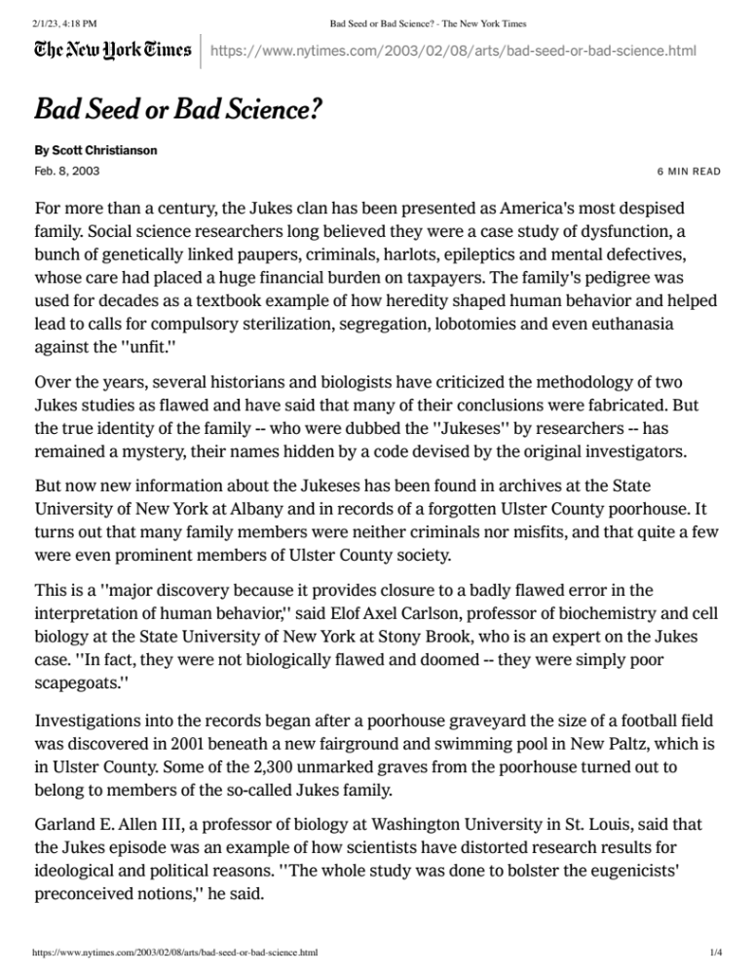

Sources

Larson, Neil G. (September 1982). "National Register of Historic Places Registration: Binnewater Historic District". New York State Office of Parks, Recreation and Historic
Preservation.

"National Register Information System". National Register of Historic Places. National Park
Service. March 13, 2009.

Smedman, L. (2022, December 5). The Binnewaters/Jukes Connection [web log]. Retrieved from
https://hurleymtn.com/the-binnewaters-jukes- connection/?fbclid=IwAR0oMOwleelBVxT128U50yerSZot- 4JqyZM5pHlvYU37cOLXoitKsKApXK8

Strange Colony in Ulster. (1897, May 31). New York Times, p. 3.

